Name: | ____________________________________ |  | Date:_________
 | Year 10 Mathematics  $\frac{ }{30}$  Test 1 - 2020  Topic – Similarity and Congruency
Total Time: | 30 minutes
Weighting: | 5%
Equipment: | 1 page of notes (back and front), Calculator, Stationary
Answer all questions in the space provided.
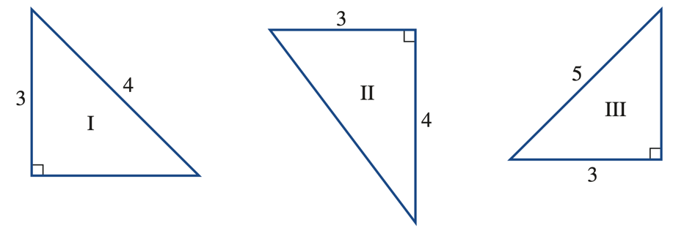
Q1: Determine which of the following pairs of triangles are Congruent [2 Marks]

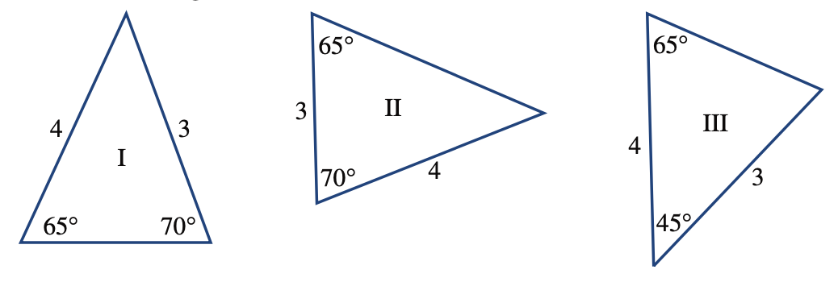
b)

Q2: Write a statement for the two triangles below. Ensure that you include enough evidence to prove your point.
[4 Marks]
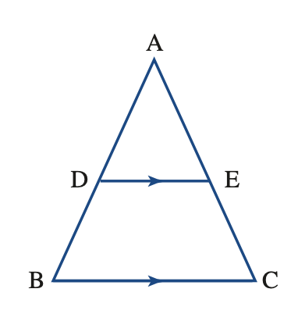

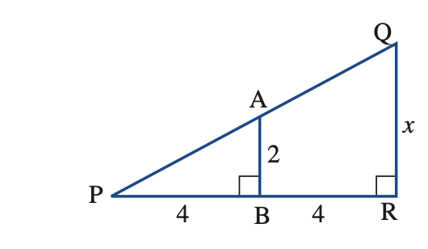
Q3: The triangles below are similar. Find the value of the missing pronumeral. [2 Marks]

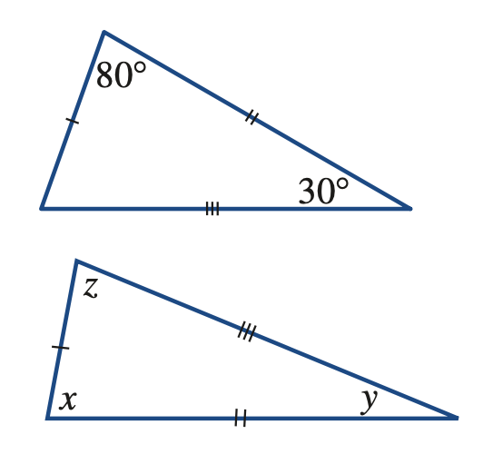
Q4: Find the value of the pronumerals in these similar triangles. [3,5,4 = 12 Marks]
a.

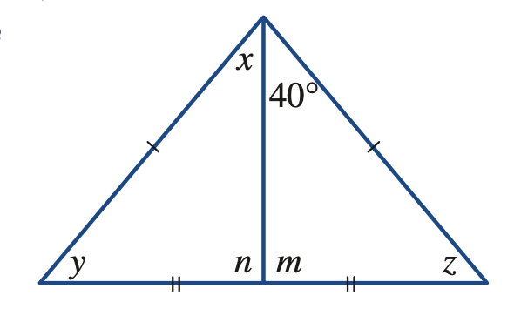
b.

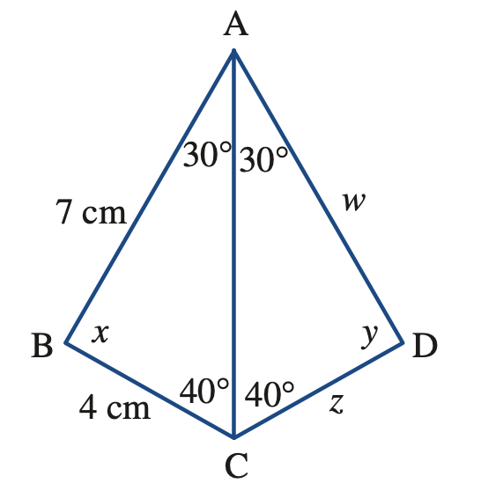
c.

Q5: Shaun puts a pencil up to his eye, and measures his friend Delilah to be the same 15cm. The pencil is 42.5cm from his face. If Delilah is 5.015m away from him, how tall is she in real life? [4 marks]

Q6: Two buildings are built in a ratio. One building is 41 floors high, each floor being 2.8m tall. The other building is 120 floors high, each with a height of 3.35m tall. [4,2 = 6 Marks]
a. Given that the larger building is 200m wide, how wide is the smaller building?

b. What is the ratio of the width to the height of the buildings?

